Software Requirements Specification
For
Divine Hotel Management System (DHMS)
Version 1.0
Prepared by: Ahmer Mirza
Roots IVY International University
October 10, 2018
Table of Contents
Table of Contents ii
1. Introduction 1
1.1 Purpose 1
1.2 Document Conventions 1
1.3 Intended Audience and Reading Suggestions 1
1.4 Product Scope 1
2. Overall Description 2
2.1 Product Perspective 2
2.2 Product Functions 2
2.3 User Classes and Characteristics 2
2.4 Operating Environment 2
2.5 Design and Implementation Constraints 3
2.6 Assumptions and Dependencies 3
3. External Interface Requirements 3
3.1 User Interfaces 3
3.2 Hardware Interfaces 3
4. System Features 3
4.1 Guests Management: 4
4.2 Reservation Management: 4
4.3 Check-in Management: 4
4.4 Check-out Management: 4
4.5 Inventory Management: 4
4.6 Amenities Management: 4
4.7 Employees Management: 5
4.8 Rooms Management: 5
4.9 Room Type Management: 5
5. Other Nonfunctional Requirements 5
5.1 Performance Requirements 5
5.2 Security Requirements 5
5.3 Software Quality Attributes 6
6. Appendix: 7
6.1 Appendix A: Model Analysis 7
6.2 Appendix B: Prototypes 9
6.3 Appendix C: GitHub Repository Links 9

Introduction

Purpose
The system being developed is called Divine Hotel Management System (DHMS). This is the first version of the document. It contains introductory details of the requirements of the system that is going to be developed. From various features of the system and running environment to implementation, the document contains each and every aspect of the system that is of the requirement. The system is going to offer a wide range of useful features that will help the hotel in its everyday processes. This document describes in great details all the individual features that system will have and its structure at different level for a better understanding of the system.

Document Conventions
The font style that has been used throughout to write this document is Times New Roman. The main headings are written with font size 18pt and subheadings with font size 14pt, while the paragraphs are written with the font size 12pt.

Intended Audience and Reading Suggestions
The document is intended for different stakeholders. This may include the examiner, designer and developer, users and maintenance programmers. The document contains details about all the aspects of this project. Further, it contains all the details of the system which is being developed and description of all of its features. It will help its readers understand the system, its features, different graphical representations of the system and system limitations. Different parts of the document can help learn about the system intended for the different people mentioned earlier.

Product Scope
The system being developed is going to help Divine Hotel computerized its daily operation. It will help the management of the hotel to perform their daily tasks more easily. Since, now the system will become a digital one, it will help the management to save and retain all the information being fed into the system daily in a more precise way and keep track of all the transactions happening on daily basis. User will be able to make reservations for the expecting guests. Inventory will be managed and keep record for easily now. Details about the employees will also be managed all in one place.
The system will provide a new, efficient and friendly working environment for the employees to work with. The new system is definitely going to help the hotel benefit their business strategies. With the hotel operations being carried out in a more streamlined manner, the management will have more time emphasize on the company’s goals in order for it to continue to groom as a successful business. The system with its easy to use and efficient features will eliminate all the problems and issues that the hotel is currently facing by digitalizing all the operations. It will enable all the users to complete their tasks in time. The system is going to offer a solution that will help daily tasks to be completed in a matter of few clicks, keeping the workflow and general continuity of the system intact.

Overall Description

Product Perspective
There is no previous version of Divine Hotel Management System. It is being designed and developed from the scratch. It is going to completely replace the previous paper-based reservation system that the hotel is using currently, with a new computer-based digital solution. It doesn’t relate to or a part of any other system. The DHMS is going to be a fully functional and independently working application software on its own. There won’t be any need for an internet connection for the system to work and will be an offline-based solution for the hotel.

Product Functions
The system is going to perform a lot of daily tasks with its numerous functions. This functionality that the new system will provide is going to speed up all the processes of the hotel. List of these functions is as follows:
Manage guests
Manage reservations
Manage check-in
Manage check-out
Manage inventory
Manage amenities
Manage employees
Manage rooms
Manage room types

User Classes and Characteristics
The end users that are going to use the system are the hotel’s receptionist and manager. The receptionist will use the system most of the times for the daily processing of reservations for the new upcoming guests and for the one that are leaving. He will also be doing most of the work related to the system in any aspect. Guest’s data will be saved and managed by the receptionist.
On the other hand, the manager may use the system sometimes to keep track of all the listings and details being saved in the system and/or to add new ones. He may use the system to keep track of the inventory being keyed in into the system. He may also use the system to add new amenities into the system if the hotel decides to bring new amenities for their guests. Both users are expected to be computer literate and have the basic knowledge of using computer systems.

Operating Environment
The system will be operated on an Intel’s Core i5 processor based computer system. It will have 500GB free space on the hard disk drive, with the basic input/output devices attached (more importantly LCD monitor display, keyboard and a mouse) for the system to run and work at the best of its capabilities. The suitable operating system used for this purpose will be Microsoft Windows 7 Professional Edition.

Design and Implementation Constraints
As for the moment, there are no such implementation constraints. There are also no hardware limitations. Instead, sufficient resources are available to sustain the system to work without any sort of trouble. The tools that will be used for designing and developing the system are easily available and free to use. Microsoft Visual Studio Community Edition will be used to develop the system. The system will work along with SQL Server Management Studio by Microsoft as database management system for configuration, integration and management purposes.

Assumptions and Dependencies
The system being developed doesn’t depend on any other sort of software. Each part of the system will be developed and work completely on its own without depending on any other system.

External Interface Requirements

User Interfaces
The system is going to have a very clean and friendly User Interface design. It will be a minimalist design to improve focus for the user as much as possible. From the Main screen, the user would be able navigate to different screens of the system using the button panel on the left hand side of the screen. User will enter data within the designated fields guided by the text labels that will tell the user what data is required and where it is required. Data will be display in table format with each data element having its own data grid. Help will be provided and error messages will be displayed if prompted. The simple user interface will allow for easier interactions with the system. Color scheme will be of the choice that may put little to no strain on the eyes, with a contrast of lighter background set against dark colored text.

Hardware Interfaces
The basic input/output devices will be used to interact with the system. This includes a keyboard, mouse, LCD monitor display, etc. Keyboard and mouse will be used to enter new data or modify the previously existing data, whereas display monitor will, of course, show current state and the processes taking place within the system. No other hardware interface of requirement have been identified other than the ones mentioned here.

System Features
The system will provide with a whole lot of helpful and easy to use features to bring out the best in almost every aspect of the management of the hotel. These features will play an important role in shaping the workflow, while also enhancing the performance of operations that are performed on a daily basis. The overall management will become more efficient and effective with these powerful features. List of these features and their descriptions are as follows:

Guests Management:
This feature will allowing for saving and keeping track of details about all the guests. It will allow to save, delete and update guest’s info when needed. It will also display all the info of all the guests in a tabular format, such that there will be dedicated cells for each attribute describing the guest. This feature will save only the basic details about the guests before handling it to the next feature.

Reservation Management:
This feature will allow the user to reserve a room for the upcoming guests. The user will insert all the required information into the system. This is one of the most used and vital feature of the DHMS and will allow for quick reservations. This feature will also view details about all the reservations that guests have made. The guests will be able to append different amenities in their reservation. An expected sum of all of this that the system will calculate that user would tell to the guest first hands. It will display all of this data in a tabular format with dedicated cells for each piece of information required. From check-in date to check-out date, this feature will not only saving and deleting a reservation but will also allow for updating it in case the guests wants to extend his/her reservation period.

Check-in Management:
This feature will allow guests to check-in to the hotel. The user will find a suitable room of the type that guest had made a reservation for. All the incoming guests who either have made a reservation or are just taking their chances at will provide all the required information to get done with their check-in process. Here, the guest will be pay some amount (usually more than the total reservation amount) to be able to check-in, that will also be keyed into the system. After that, the guests will finally be able to move into their respective rooms. This feature will also display all the information about all the check-ins in a tabular format of all those guests that have checked into the hotel so far.

Check-out Management:
This feature will allow for guests to check-out of the hotel. Once the guest decides to leave, he/she will provide the user with their room number. The user will select their room number in the check-out feature of the system, and will also make sure it if there’s any remaining amount still left to be paid either by the guest or the hotel. Once done, the guests will be checked-out and able to leave hotel. This feature will also display information about all the check-outs in a tabular format that guests have made.

Inventory Management:
This feature will allow to view all the current inventory and its information that the hotel has in a tabular format. It will also allow to save all the new inventory items information into the system or delete or update details for previous ones.

Amenities Management:
This feature will allow to manage all the amenities that hotel can offer. It will be all the services that guests can avail while they are staying at the hotel. This feature will allow to not only add new amenities but also delete or update details about the previous ones. It will also display all the amenities that hotel is currently offering in a tabular format with dedicated cells for each attribute of information.

Employees Management:
This feature will allow to manage all the information of the employees that are currently work at the hotel. All the information will be available for user to view in a tabular format with dedicated cells for each piece of information. It will not only allow to save new employees details but also delete and update information for the previous ones.

Rooms Management:
This feature will allow to manage all the rooms that the hotel has right now. It allow to add new rooms of all the types available into the system. It will not only allow to add new rooms but also delete and update details for previous ones. The feature will display all these rooms that the hotel has in a tabular format. It will also show the current occupied status of the rooms here.

Room Type Management:
This feature will allow to manage all the room types that hotel can offer right now. It will allow to add a new room type that hotel is going to offer into the system. All the information describing the room type including its base charges will be available for view in a tabular format. With this feature, the user will not only be able to add a new room type but also be able to delete and update details for the existing room types.

Other Nonfunctional Requirements

Performance Requirements
The system is required to meet certain performance criteria to satisfy the user needs. It must be made sure that system will always be available for use as soon as the user requires it to be. It must respond to user needs with immediate action. The system might be required to store data or update it, and with whatever the case, it must respond within the minimum time possible. The number of crashes for the system should be from zero to as minimum as possible to ensure maximum availability.

Security Requirements
The system is expect to provide with a security mechanism that will authenticate the identity of the person who is to use the system. It will make sure that no person, other than the ones that are authorized, use of the system. Guests are often concerned about the privacy of their personal data that the system will save, data that mustn’t be available for anyone to view, with few authorized exceptions, the system will provide with a layer of security to avoid any potential breach. It will provide with a login screen that only the authorized people will be able to pass through with their login credentials, to reach the system in order to view or modify data.

Software Quality Attributes
The system must display certain quality traits in processes taking place within the system. These traits will be a direct proof of how good or bad the system is, therefore these traits must contribute to display a level of satisfaction when it comes to the actual user of the system. The system must stay available at all cost allowing the user do his job anytime he is required to do so. It is expected to be a robust one to withstand the rigorous use. It must allow for recovering from any unexpected error or mistakes made by the user of the system. It must also show a certain level of correctness in the data being displayed to the users and as well as the data which is to be conveyed to the guests.

Appendix:

Appendix A: Model Analysis
The following Use case diagram was made during the development of the system.
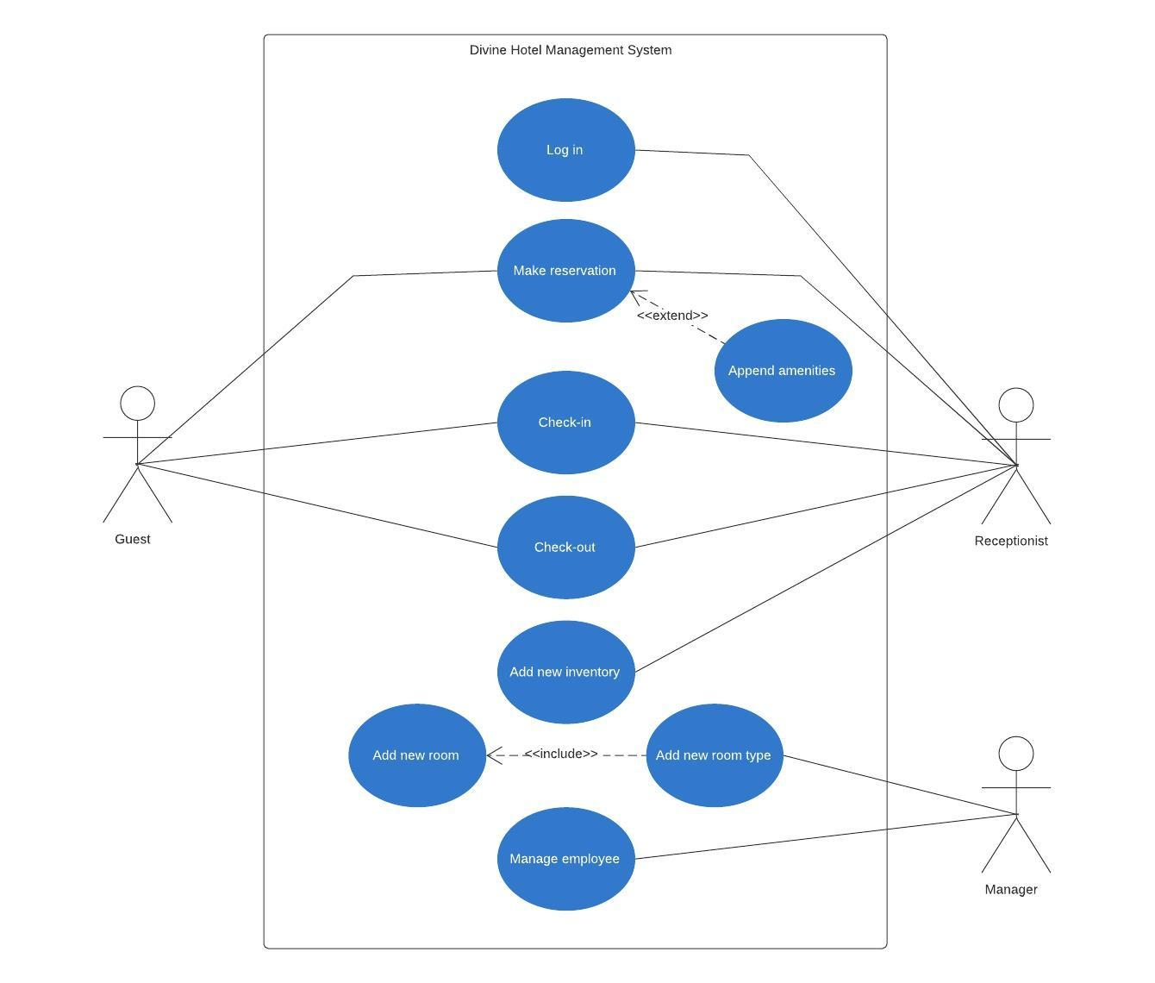
Diagram: Use case diagram for DHMS

The following Entity-Relationship diagram or ERD was made during the development of the system.

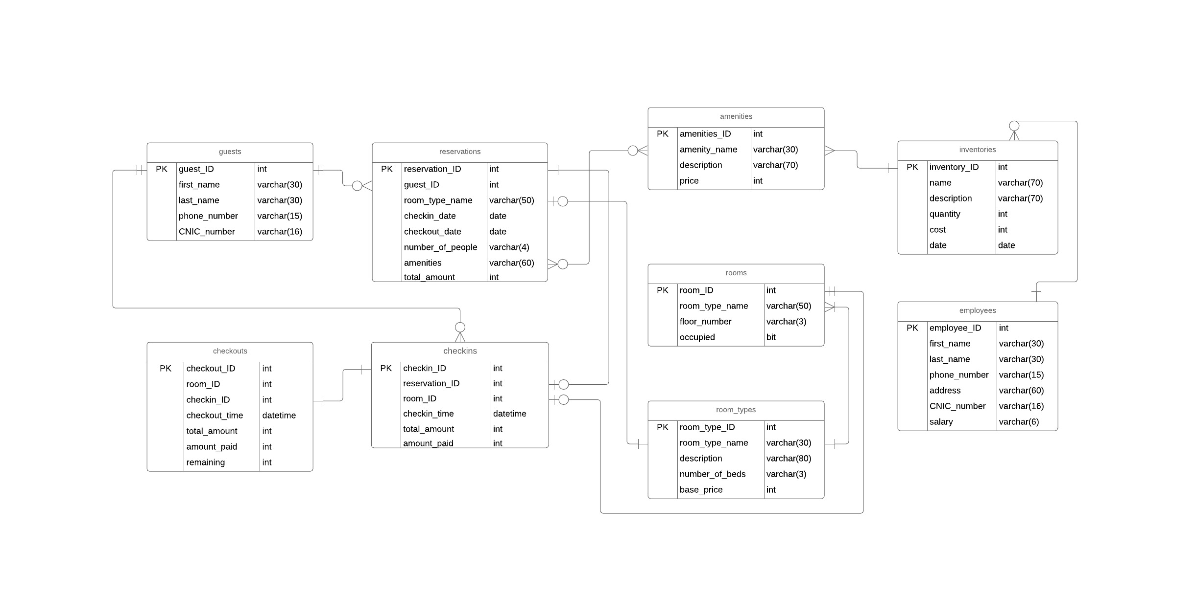

Diagram: Entity-Relationship diagram for DHMS
The following Class diagram was made during the development of the system.

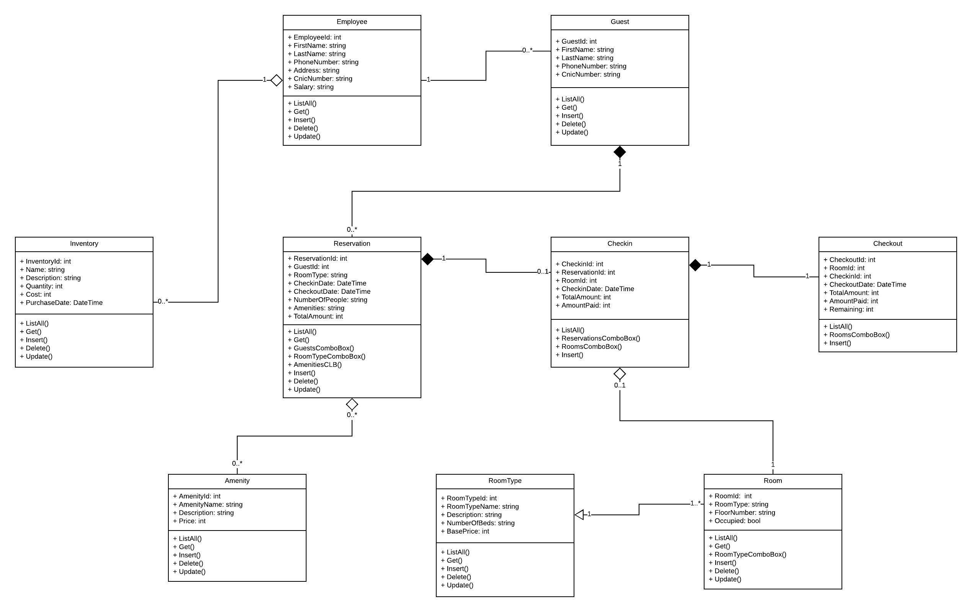
Diagram: Class diagram for DHMS

Appendix B: Prototypes
Please refer to the “Prototypes for DHMS” document for all the final prototypes of the system.

Appendix C: GitHub Repository Links
Link 1: Project repository link

https://github.com/ahmermirza/Divine-hotel-management-system.git

Link 2: Project documents repository link

https://github.com/ahmermirza/project-documents.git

